EE 223 Homework 4

Enrique Hernandez

11/04/2018

Design of High-Swing Cascode Bias and Cascode OTA Circuit

1. Schematic and DC Operating Points of the Circuit

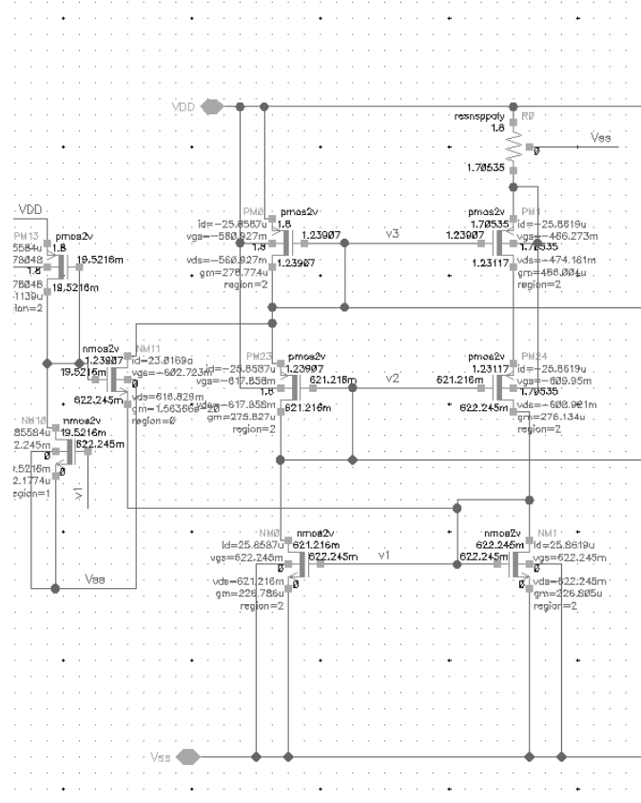

Figure 1: Start Up Circuit and Beta Multiplier DC Operating Points and Node Voltages

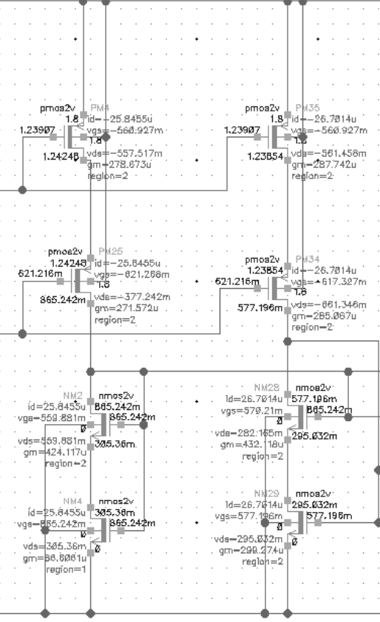

Figure 2: Nmos High Swing Current Cascode DC operating point and Node Voltage.

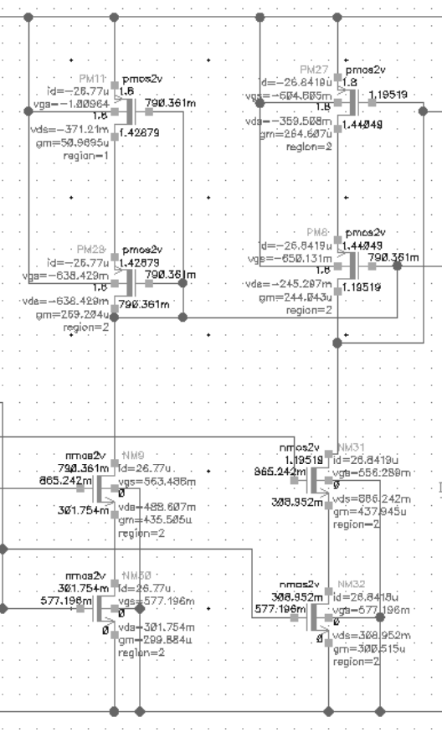

Figure 3: Pmos High Swing Current cascode DC operating Point and Node voltage.

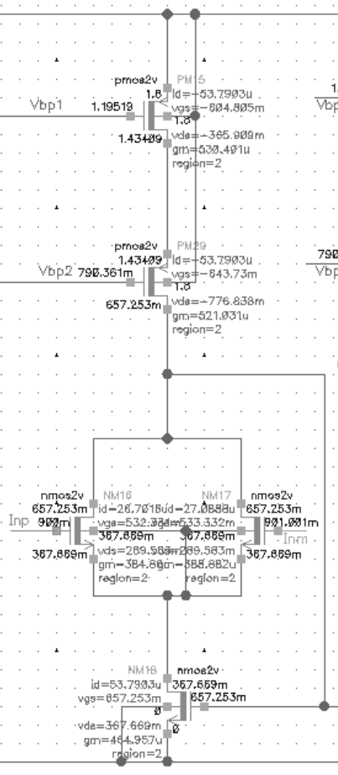

Fiugre 4: Fully differential DC Operating point and Node voltage.

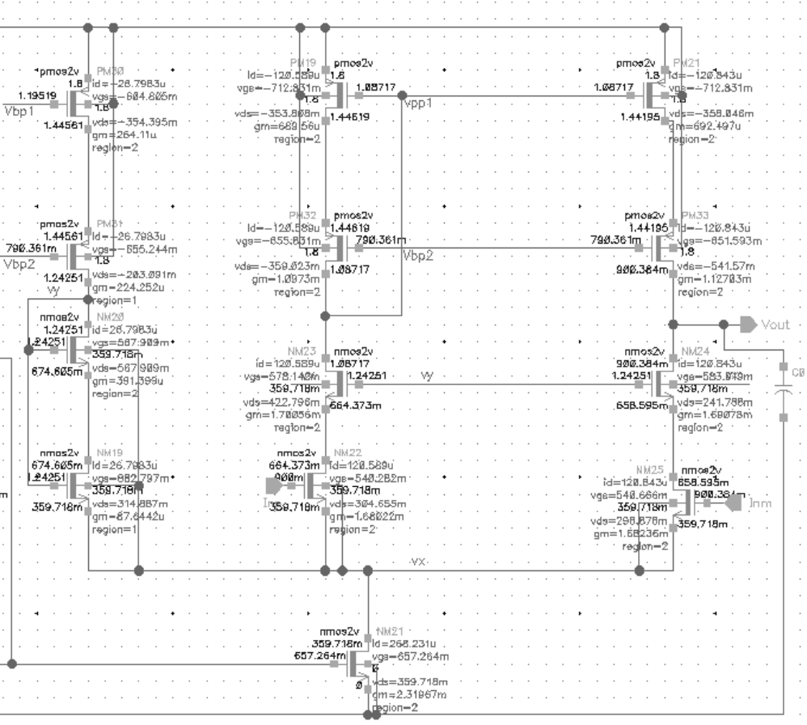

Figure 5: Operational Transconductance Amplifier DC Operating point and Node Voltage.

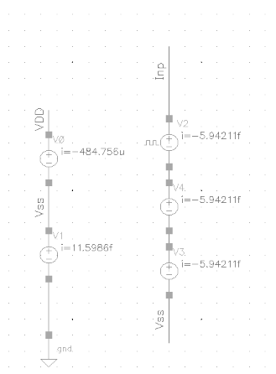

Figure 5: Circuit Power dissipation VDD= 1.8V, I=484.755uA, P=872.561uW (VDD*I).

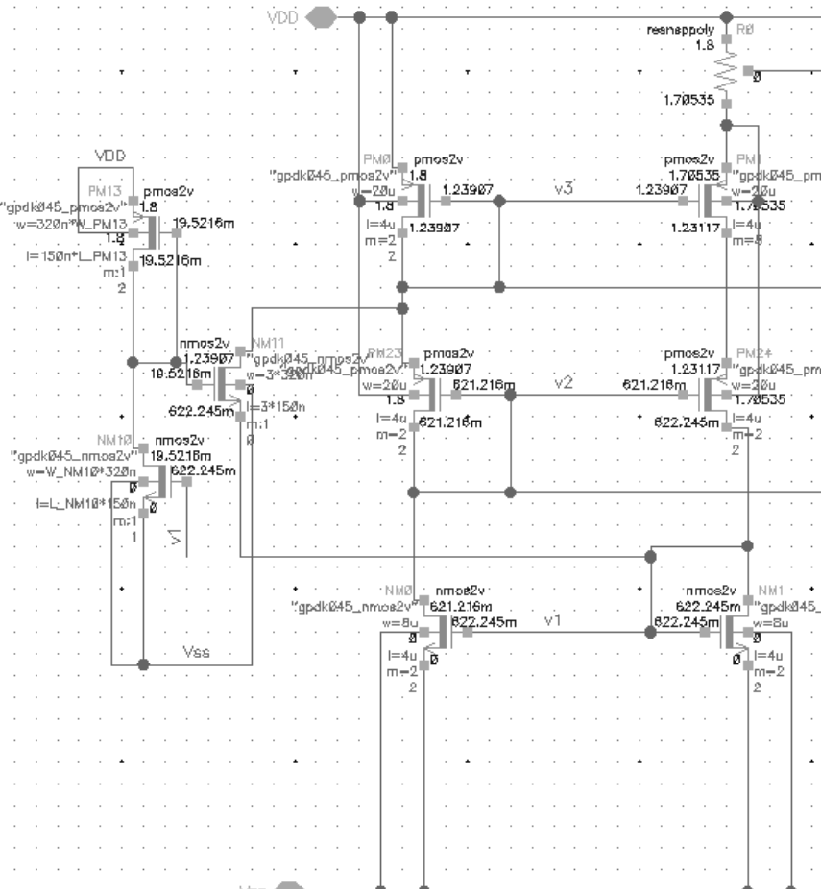

Figure 6: Start Up and Beta multiplier device size and region of operation. Where w_pm13=1, W_PM13 = 50, L_NM10=2 and W_NM10=10.

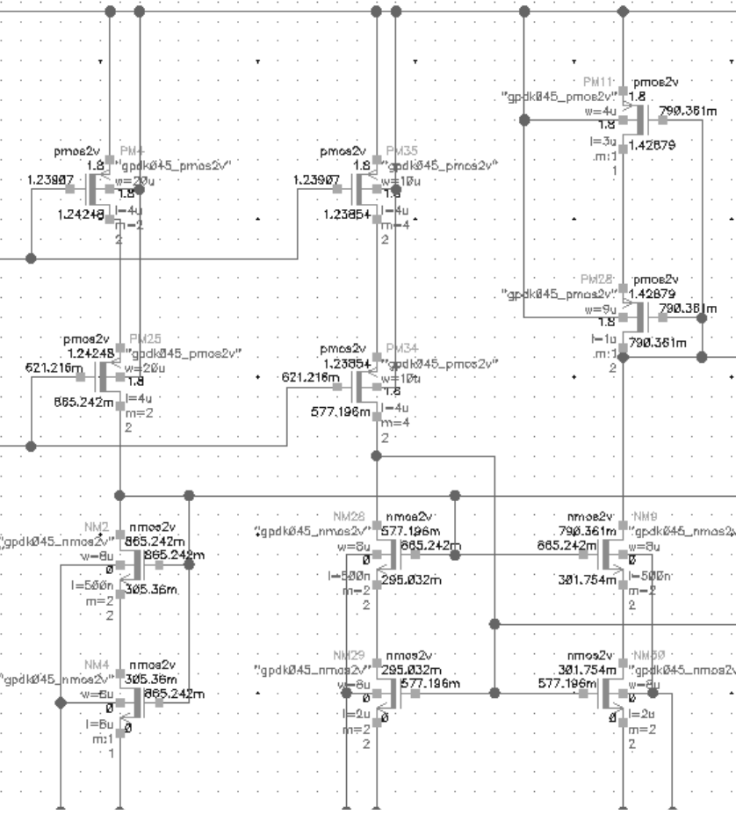

Figure 7: NMOS high swing current cascode device size and DC operating region.

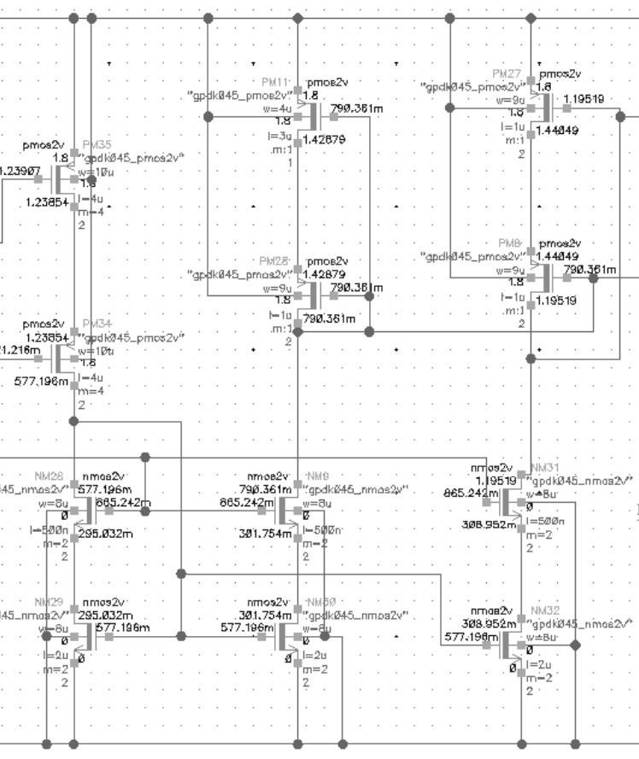

Figure 8: PMOS high swing current cascode device size and DC operating region.

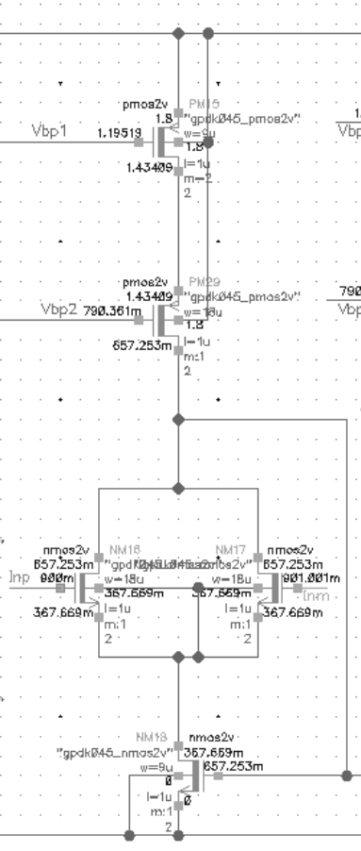

Figure 9: Fully differential circuit device size and DC operating region.

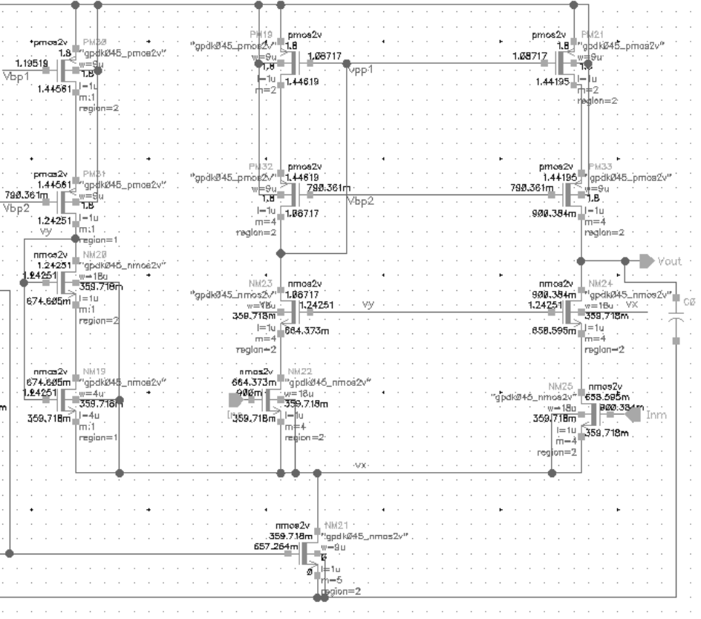

Figure 10: Operational Transconductance Amplifier devices size and DC Operating region.

1. AC Simulation and results.

Schematic

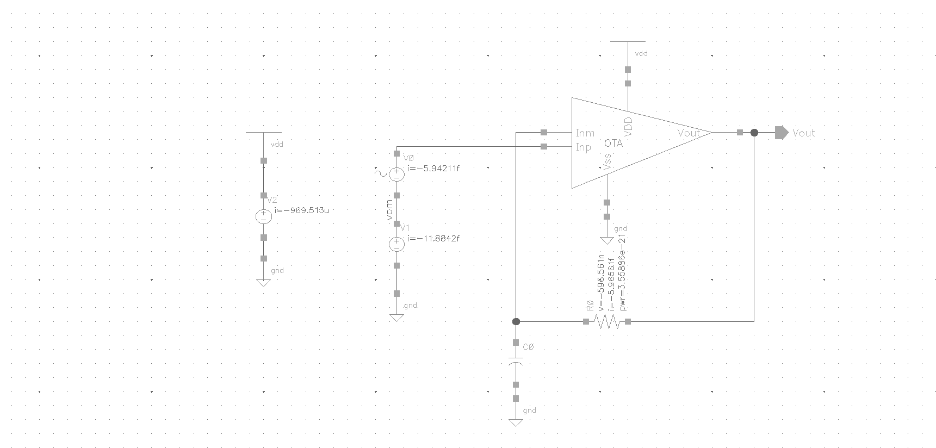

Figure 11: AC response schematic

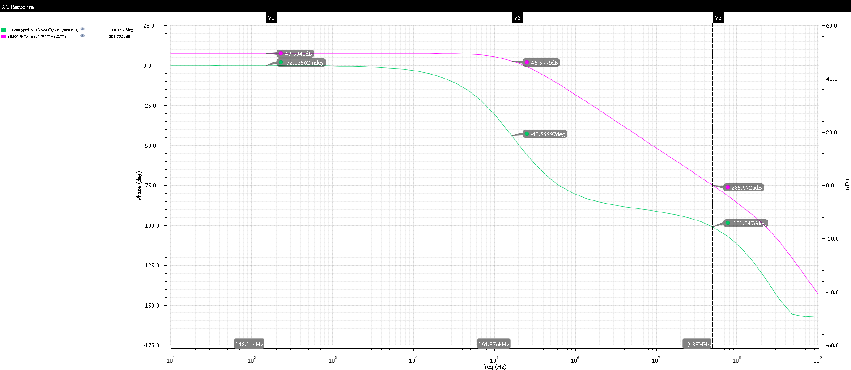

Figure 12: AC response plot

Table 1: AC response Results

|  |  |  |
| --- | --- | --- |
| Parameter | Gain[dB] | Frequency[HZ] |
| A0 | 49.501 | 0 |
| -3dB BW | 46.59 | 164.57K |
| Wu | 0 | 49.88M |
| A0*-3dB BW |  | 49.1182M |

1. Transient simulation of Buffer configuration

Schematic

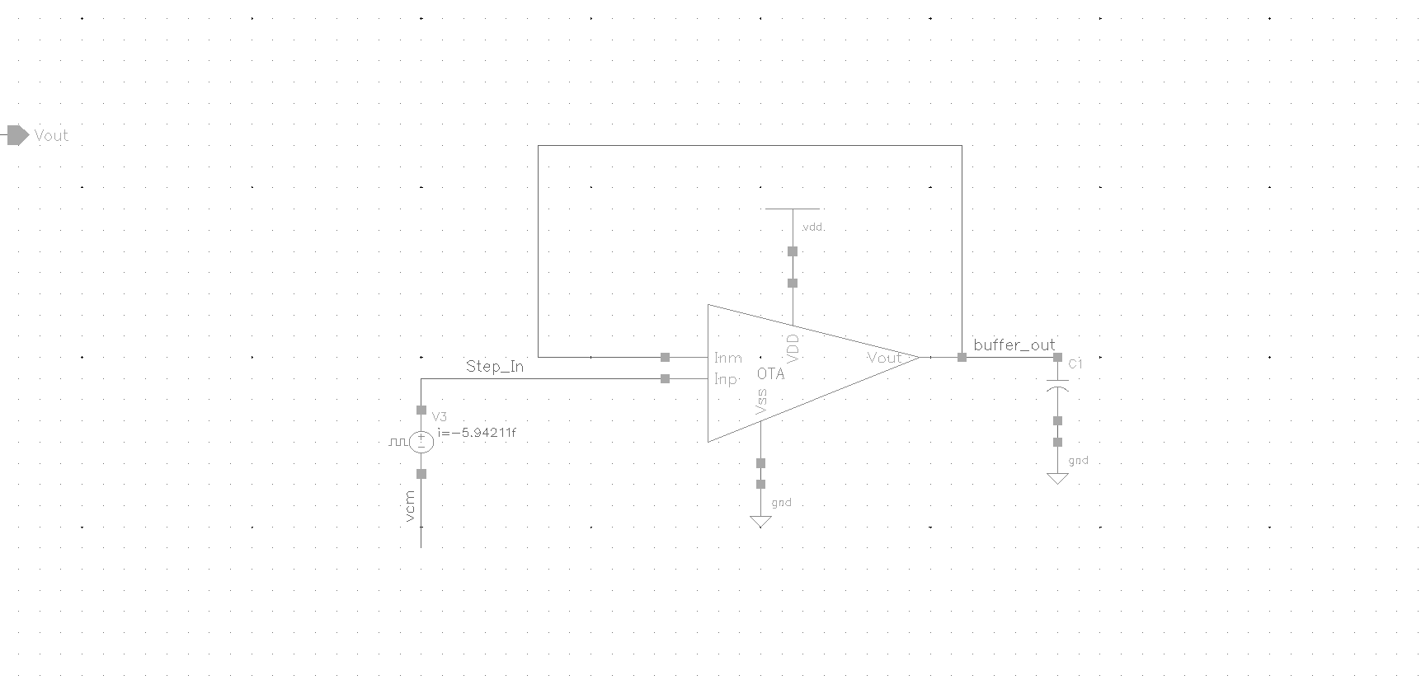

Figure 13: Unity gain configuration circuit.

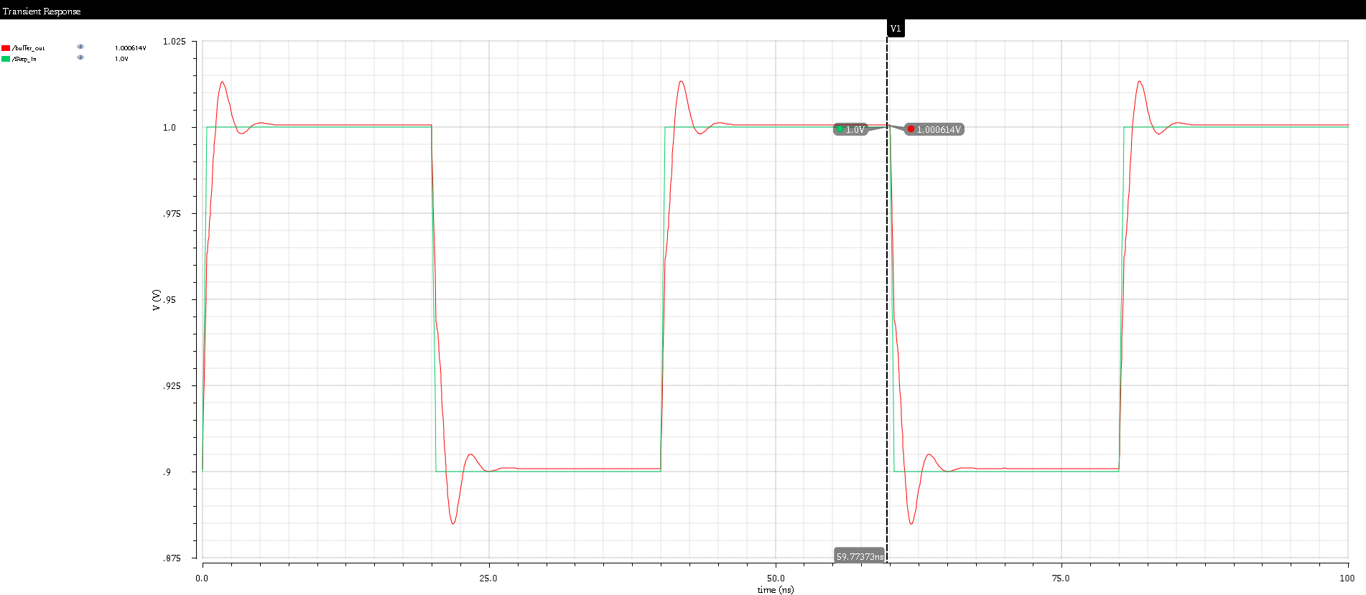

Figure 14: Transient Response of the Unity gain configuration (red trace is output, and green is input).